Name: |  | Date:
 | Year 7 Mathematics  Term 4, 2021  Design a Zoo Project  Resources Allowed:  Calculators, grid paper, pen, pencil | Total Marks:

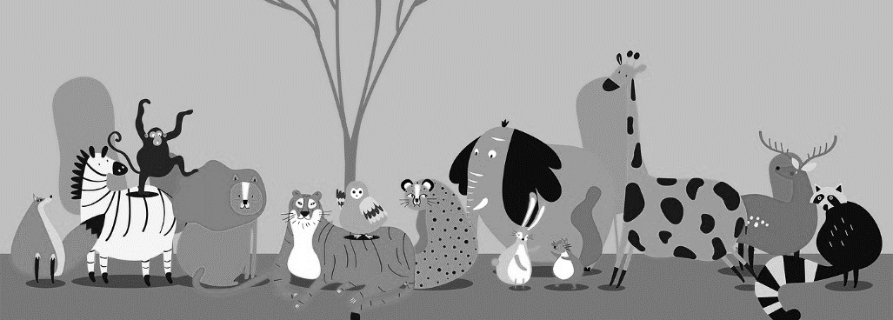
Design your own zoo

You have been chosen as a member of the design team to put together the plans for the new Perth Zoo development. Use the checklist and guidelines to design your zoo.

As a class brainstorm: What do you need to consider when designing a zoo?

Checklist:
- Choose at least 10 different animals to include in your plan
- You must include two of each animal, but you may include more
- Research what type of habitat requirements different animals may need
- Consider if the animals need enclosed areas like inside of buildings for controlled climates (very cold, hot or wet) and if animals need aquariums, large open spaces, or water sources
- Some animals can be grouped together in the same exhibit
- Determine the amount of area your exhibit will have – using the chart on the back to find the minimum requirements for one animal
- Complete the “Zoo Planning Sheet” and “Area and Perimeter Sheet”
- Use grid paper to draw a map design of the animal exhibits (which animals will you put near each other)
- Add at least 4 extras
- Label all exhibits and extras on your design
Mammals |  | Birds
Animal | minimum area (m²) | Animal | minimum area (m²)
Zebra | 200 | Peacock | 100
Elephant | 200 | Ostrich | 200
Giraffe | 200 | Emu | 200
Hippo | 200 | Owl | 100
Rhino | 200 | Toucan | 100
Anteater | 150 | Stork | 100
Kangaroo | 150 | Flamingo | 100
Camel | 150 | Macaw | 100
Llama | 100 | Eagle | 200
Hyena | 100 | Vulture | 150
African painted dogs | 100 | Reptiles
Sloth | 50 | Animal | minimum area (m²)
Koala | 50 | Crocodile | 100
Red panda | 100 | Galapagos Tortoise | 100
Echidna | 50 | Snapping Turtle | 50
Bats | 100 | Boa Constrictor | 50
Orangutan | 100 | Iguana | 20
Lion | 200 | Perentie | 50
Tiger | 200 | Amphibians
Leopard | 250 | Animal | minimum area (m²)
Cheetah | 250 | Poison Dart Frog | 10
Panther | 250 | Bullfrog | 10
Black Bear | 150 | Cane Toad | 10
Wombat | 100 | Fire-Bellied Newt | 10
Wallaby | 100 | Salamander | 10
Meerkat | 50 | Blue tongue lizard | 10

Use the following list of animals to help plan your zoo design. The minimum amount of area required for each individual animal is listed in the table. You must consider how many animals of each type you will be including. For example: each zebra needs 200 m² of space so if you have a herd of 7 zebras in your zoo design plan you will need 7× 200 m² = 1400 m² for your zebra exhibit.

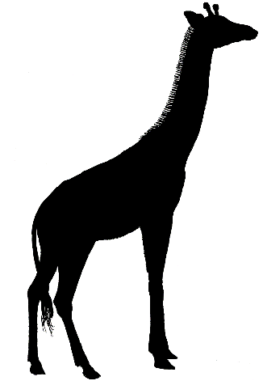

Zoo Planning Sheet
Animal | Quantity | Area (m²) | Habitat Considerations

To Consider:
Are there any animals with similar habitats that you could include in the same exhibit?
Which animals could you put near each other?
Drawing your design:
You can use multiple grid papers if needed. Each grid line represents 2m.
Label all exhibits and extras with their measurements
Include an entrance/exit
Area and Perimeter
Exhibit |  | Dimensions | Area (m²) | Perimeter (m)
1
2
3
4
5
6
7
8
9
10
Extras |  | Dimensions | Area (m²) | Perimeter (m)
1
2
3
4

